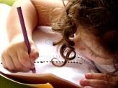  Literacy  In Literacy we will be following our Talk 4 Writing scheme. Our first unit involves a fiction Rags to Riches tale about a Pirate called Tom. We will then use our Pirate Knowledge in our non-fiction unit when we create a persuasive leaflet for a Pirate Adventure Park. | 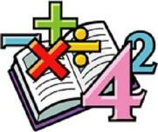  Maths  In Math we will be learning about place value including hundreds, tens and ones. We will be estimating, ordering and comparing using number lines. We will then move onto addition and subtraction including subtracting multiple 1-digit and 2-digit numbers. | Science  We are learning about the use of everyday materials including wood, metal, plastic, glass, brick, paper and cardboard. We will be performing simple tests so that we are able to choose materials suitable for a particular purpose. | 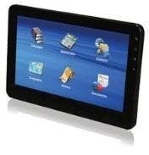  Computing  We will begin this subject with Online Safety; identifying what is meant about keeping ourselves safe online. This includes sharing personal and private information, understanding that we have the right to withdraw consent and that not everything we encounter is true.
Humanities  In Geography we will be naming, locating and identifying characteristics of the four countries of the United Kingdom including cities, flags and national flowers.  In History we will be finding out about kings and queens. | 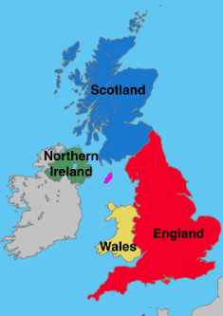  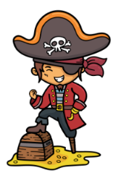  Year 1/2  Overdale Community Primary School  Autumn Term 1 2023  Big Question: Where in the world is the United Kingdom ? |  | 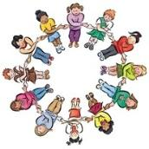  PHSCE In PHSE and RSE we will continue developing our knowledge and skills surrounding families and relationships. We will build on our understanding around how all families and friendships are different. We will also be taking part in a daily circle time.
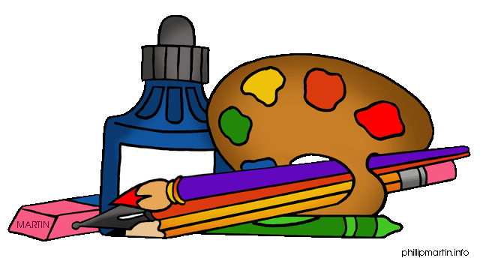  Art and DT  In Art we are exploring the formal elements of Art including using repeating lines, shapes, tones and colours to crate patterns. In DT we will be developing our sewing skills to use a running stitch among a template to create a pouch. | PE  In P.E. we will be completing an animal dance unit using our bodies to create theme related shapes, movements and actions. We will also be taking part in the daily ½ a mile. | Music In music we will explore traditional western stories through orchestral instruments including The Three Bears, The Snow Queen, Red Riding Hood and Jack and the Beanstalk. | RE In RE we will be thinking about the question. ‘Who is  Jewish and what do they believe?’
Reading: Children will be expected to read their home reading books three times a week with a written comment from a parent in their reading record. Children will also have access to their class Lending Library where they can bring home alternative books to read for pleasure with an adult. Some children may also start to bring home stretch and challenge books to accompany their weekly reading sessions.
Maths: We will be focusing on place value, including hundreds, tens, and ones – any help at home with this would be great – thank you
Spelling: Each week, your child will bring home weekly spellings that the children will need to learn for a weekly spelling test on Friday. These spellings accompany our phonics learning in class.
Homework: Your child will bring home a homework book this term. Inside the homework book is a ‘Menu’ of activities should you wish to complete. These activities are optional but do complement our learning in school.

